PerkoBot Documentation

Smart Systems Lab

**PerkoBot**

PerkoBot is an autonomous smart robot.

HARDWARE

PerkoBot Main Processor: NVIDIA Jetson AGX Xavier

Power Supply: 24v

Memory: 32gb

CPU: 8 core ARM  
Storage: 32GB eMMC 5.1

Expansion Header (NEEDS VERIFICATION):

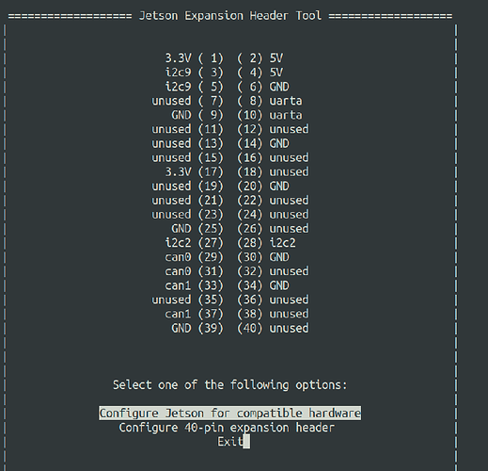

SOFTWARE

ROS Melodic on Nvidia Xavier AGX:

<https://www.youtube.com/watch?v=HjFs00rrJfY>

<https://www.jetsonhacks.com/2018/10/26/robot-operating-system-ros-on-nvidia-jetson-agx-xavier-developer-kit/>

Jetson Developer kit version:

Steps:

Three main Git repos: